PROBLEM 1

>> load('handel.mat')

t0=cputime;
Y=fft(y);
yTime=cputime-t0

yTime =

0.4910

>> hallelujah=y(1:65536);
t0=cputime;
Y=fft(hallelujah);
yTime=cputime-t0

yTime =

0.0770

>> [y_size, t]=size(y);
y_size

y_size =

73113

>> % Since the original size of y is 73113x1 and hallelujah is 65536x1
>> % hallelujah is smaller than y and hence requires less cpu time.

PROBLEM 2
>> load('handel.mat')
i=sqrt(-1);
F4=[1 1 1 1; 1 i -1 -i; 1 -1 1 -1; 1 -i -1 i]
R=[1 0 0 0; 0 0 0 1; 0 0 1 0; 0 1 0 0]

% Since F is symmetric, F* is the same as conj(F4)
R_HerF=R*(conj(F4))

F4minusRHerF=F4-R_HerF

F4 =

1.0000 1.0000 1.0000 1.0000
1.0000 0 + 1.0000i -1.0000 0 - 1.0000i
1.0000 -1.0000 1.0000 -1.0000
1.0000 0 - 1.0000i -1.0000 0 + 1.0000i

R =

1 0 0 0
0 0 0 1
0 0 1 0
0 1 0 0

R_HerF =

1.0000 1.0000 1.0000 1.0000
1.0000 0 + 1.0000i -1.0000 0 - 1.0000i
1.0000 -1.0000 1.0000 -1.0000
1.0000 0 - 1.0000i -1.0000 0 + 1.0000i

F4minusRHerF =

0 0 0 0
0 0 0 0
0 0 0 0
0 0 0 0

>> % Note that F-RF*=0, which means F=RF*, or F=R*conj(F), since F* is the same as conj(F)
% due to the fact that F is always symmetric, so F=F' always. Since s=Fx is the Fourier
% transformation of a real sequence x and s is the complex conjugate of s,
% we have the same case as F-RF*. Thus, we can conclude that s-R*conj(s)=0, which
% means s=R*conj(s).

% Since s=R*conj(s) and power(s)=power(conj(s)), power(s)=Power(R*conj(s))=Power(R*s).
% Therefore, the only way that the power(s) can equal to Power(R*s) is if the graph is
% symmetric.

PROBLEM 3

hallelujah=y(1:65536);
temp = fft(hallelujah);
h=abs(temp(2:32769));
plot(h)

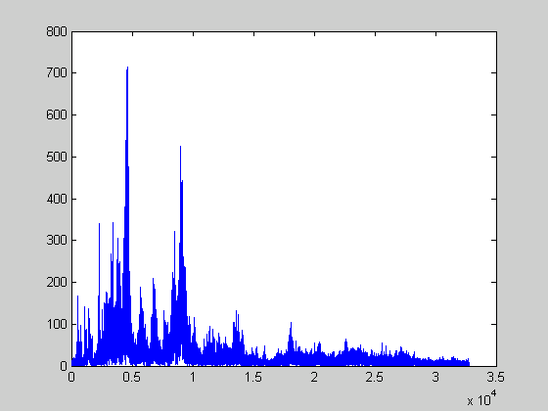

PROBLEM 4 & 5

function hw4Prob4

load('handel.mat')

hallelujah=y(1:65536);

temp = fft(hallelujah);
h=abs(temp(2:32769))

freq=(2:32769)/32769*(Fs/2);
plot(freq,h)

end

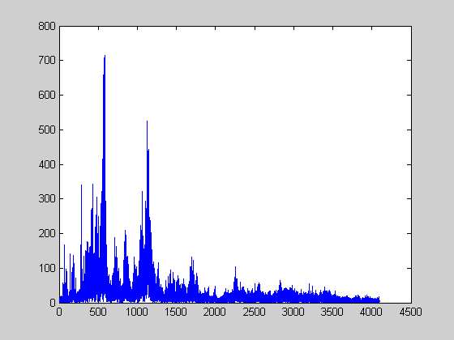

PROBLEM 6
We found 3 different links with 3 different keys:

D
http://www.afsanctum.com/pages/sg550005

C
http://home.earthlink.net/~rgpierce/hallelujah.html

B
http://tiger.towson.edu/users/leiche1/Handel's%20Messiah.htm

But we think it is B or high C since the highest peak of the plot occurs somewhere near 500Hz.

PROBLEM 7

load('handel.mat')
hallelujah=y(1:65536);
temp = fft(hallelujah);
h=abs(temp(2:32769));
freq=(2:32769)/32768*(Fs/2);
plot( freq, h, freq*(3/2), -h )

% Note how the lower graph is 3/2 of the original (upper) graph

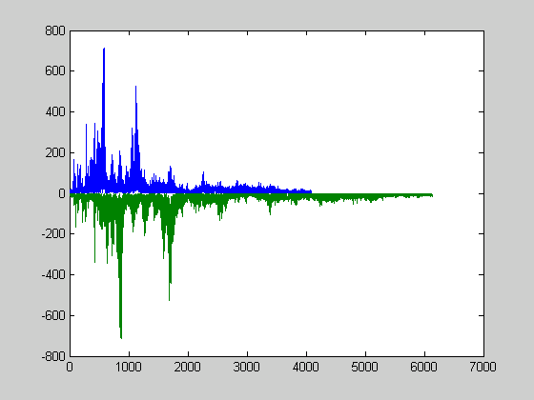

PROBLEM 8

clc

load('handel.mat')

hallelujah=y(1:65536);

temp = fft(hallelujah);
c = 2^(1/12);
temp=temp*c^7;
h = ifft(temp);
freq=(1:65536);
plot(freq,h)

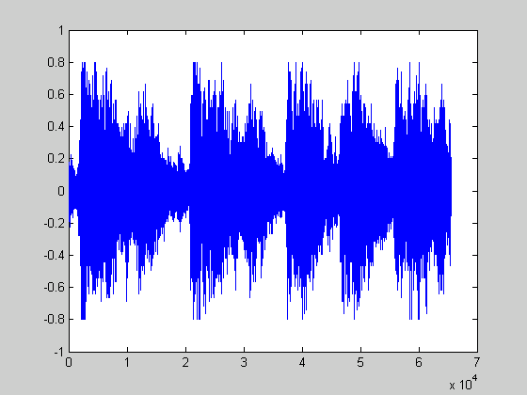

% Note how the two graphs here are very similar except one ranges from -1 to 1 and another ranges from -1.5 to 1.5 on the y-axis, i.e. the second graph is 3/2 of the first one.

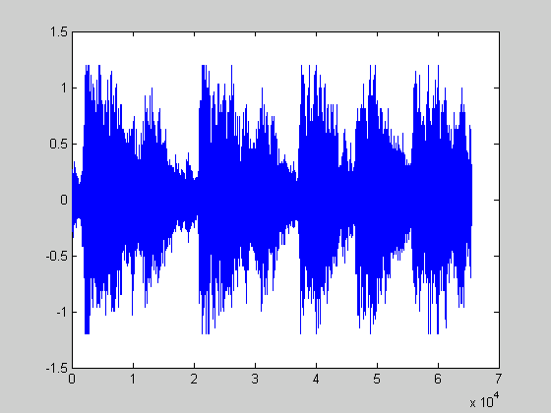

PROBLEM 9

clc

load('handel.mat')
hallelujah=y(1:65536);

temp = fft(hallelujah);
for I = 1:65536,
if temp(I)>524
temp(I) = 0;
1;
end
end

h = ifft(temp);

freq=(1:65536);

myfilter = [0.25 0.25 0.25 0.25];
tt = conv(myfilter, hallelujah)

