% Huan Mei Chen
% 502-772-876
% David Sum
% 202-779-266
% cs170a
% Hw 3

% PROBLEM 2

% define function to calculate probability that the
% given data is fraudulent, file saved as calcCert.m

function prob(a)

t = sum(a);
len = length(a);
v = 0;
for i = 1:len,
d = t*log10(1+1/i);
v = v+((a(i)-d)^2/d);
end

prob = chisquared_prob(v,len-1)

%-------------------------------------------------------------------

% test tax numbers
% number of leading 1s, 2s, etc for Bush
bushTax=[17 6 11 10 4 1 4 9 10];
% histogram
bar(bushTax)
calcCert(bushTax)
pause

prob =
0.9999

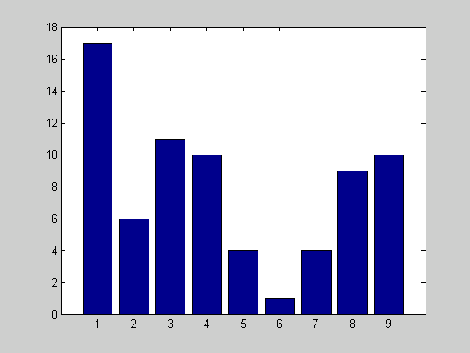

% number of leading 1s, 2s, etc for Clinton
clintonTax=[18 14 7 16 4 5 6 7 5]
% histogram
bar(clintonTax)
calcCert(clintonTax)

prob =
0.9333

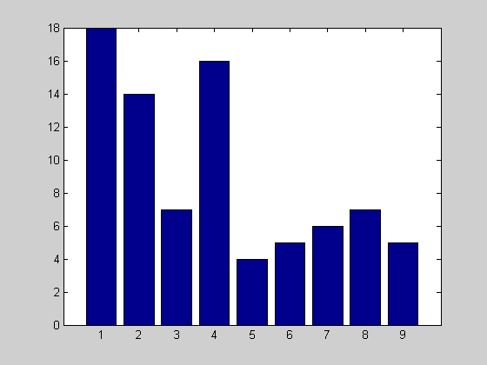
PROBLEM 3

>> hpwr=autos(:,4);
mpg=autos(:,1);
disp=autos(:,3);
wt=autos(:,5);
row=391;

% 1/mpg=alpha*hpwr+beta
A1=[hpwr ones(row,1)];
b=1./mpg;
xLS1=A1\b;
sum1=0;
alpha1=xLS1(1)
beta1=xLS1(2)
for i=1:row,
sum1=sum1+((A1(i,1)*alpha1+beta1)-b(i))^2;
end
error1=sqrt(sum1)

alpha1 =
3.6478e-004

beta1 =
0.0096

error1 =
0.1679

>> % 1/mpg=alpha*hpwr+beta*disp+gamma*wt+delta
A2=[hpwr disp wt ones(391,1)];
b=1./mpg;
xLS2=A2\b;
sum2=0;
alpha2=xLS2(1)
beta2=xLS2(2)
gamma2=xLS2(3)
delta2=xLS2(4)
for i=1:row,
sum2=sum2+((A2(i,1)*alpha2+A2(i,2)*beta2+A2(i,3)*gamma2+delta2)-b(i))^2;
end
error2=sqrt(sum2)

alpha2 =
1.2740e-004

beta2 =
2.2125e-005

gamma2 =
9.5994e-006

delta2 =
0.0015

error2 =
0.1375

>> % extra credit
% 1/mpg=alpha*hpwr+beta*disp+gamma*wt+accel*delta+theta
accel=autos(:,6);
A3=[hpwr disp wt accel ones(391,1)];
b=1./mpg;
xLS3=A3\b;
sum3=0;
alpha3=xLS3(1)
beta3=xLS3(2)
gamma3=xLS3(3)
delta3=xLS3(4)
theta3=xLS3(5)
for i=1:row,
sum3=sum3+((A3(i,1)*alpha3+A3(i,2)*beta3+A3(i,3)*gamma3+A3(i,4)*delta3+theta3)-b(i))^2;
end
error3=sqrt(sum3)

alpha3 =
1.5717e-004

beta3 =
2.5004e-005

gamma3 =
8.5843e-006

delta3 =
3.4597e-004

theta3 =
-0.0045

error3 =
0.1370

>> %compare errors
>> error1

error1 =
0.1679

>> error2

error2 =
0.1375

>> error3

error3 =
0.1370

