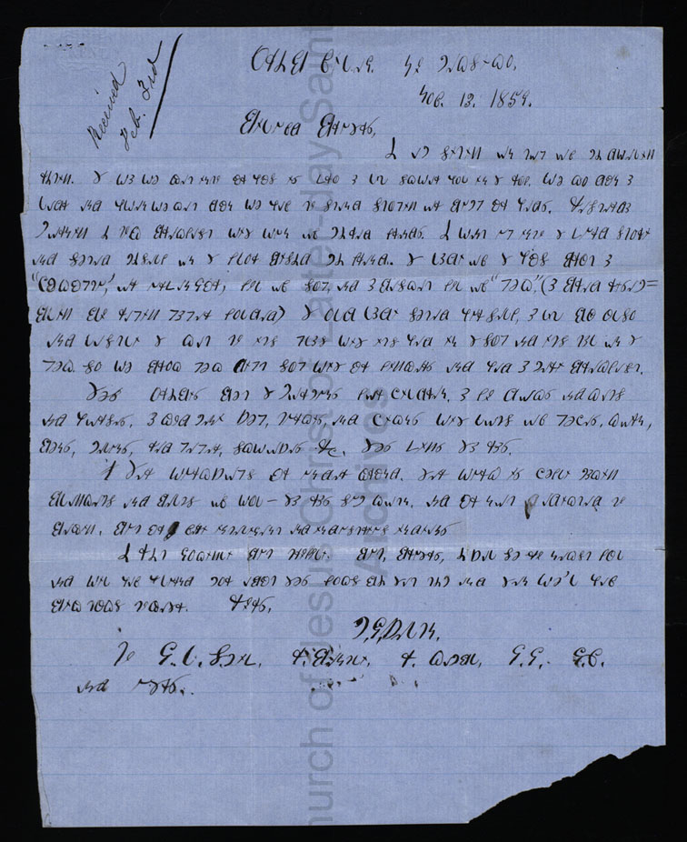



*Oribe Village. New Mexico,*

*Nov. 13. 1859.*

*Beloved Brothers,*

*I am sitting on top of my dwelling writing. The way we get into our house is thru a little square hole in the roof. We go down a ladder and when we get down we have to stand stooping or bump our heads. Yesterday morning I took breakfast with one of my red friends. I went up into the third story and seated myself on the floor beside my friend. The lady of the house brought a “chahkahptuh’, or earthen jar, full of soup, and a basket full of “piki”,(a bread resem- bling blue wrapping paper folded) The old lady seated herself, a little boy also and lastly the cat to its place with its head in the soup and its tail on the piki. So we broke piki dipped soup with our fingers and had a merry breakfast.*

*These oribes beat the Mormons for children. A few dogs and cats and horses. A good many sheep, turkeys, and chickens with lots of peaches, corn, beans, melons, and pepper, squashes &c. These things they raise.*

*I Their workshops are under ground. There work is chiefly making blankets and belts of wool – they raise some cotton. And are not d addicted to begging, but are very intelligent and industrious Indians*

*I write jokingly but truthfully. But, Brothers, I shall see you next fall and will have learned more about these folks by that time and then we’ll have big talks together. Yours,*

*M.J.SHELTON.*

*To G. L. Smith, R. Bentley, R. Campbell, J.J. J.V. and others.*