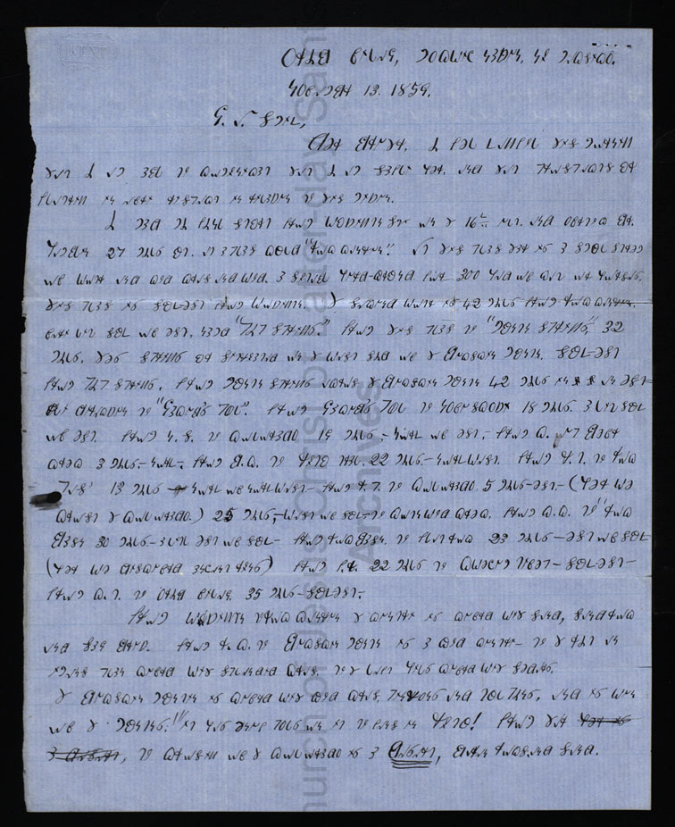

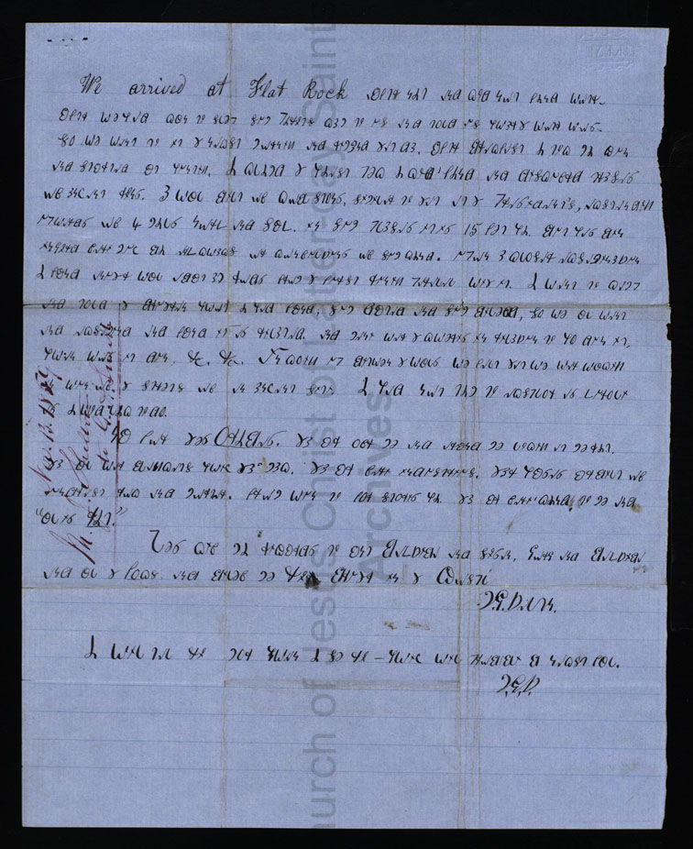

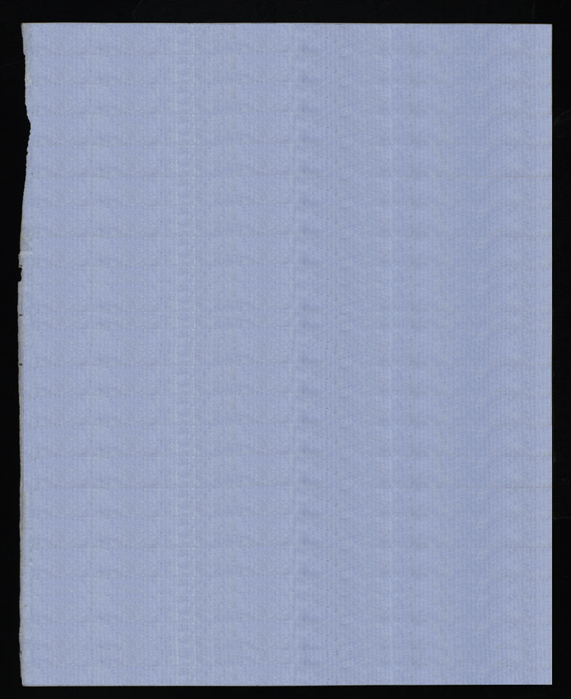

*Oribe Village, Moquich Nation, New Mexico.*

*November 13. 1859.*

*G. A. Smith,*

*Dear Brother, I feel thankful this morning that I am able to communicate that I am safely here, and that prospects are flattering in every respect in relation to this mission.*

*I made my final start from Washington Ct. on the 16th ult.(?) and overtook Br. Hamblin 27 miles out, at a place called “Rock canyon.” At this place there is a small stream of water and good grass and wood. A suitable herd-ground for 300 head of cattle or horses. this place is south-east from Washington. The second water is 42 miles from Rock Canyon, very little south of east, named “Pipe Springs.” From this place to “Mountain Springs,” 32 miles. These springs are situated on the west side of the Buckskin Mountain. South-east from Pipe Springs, from mountain springs across the Buckskin Mountain 42 miles in an east-erly direction to “Jacob’s Pool.” From Jacob’s Pool to Nova Scotia 18 miles. A little south of east. from N.S. to colorado 19 miles, -north of east,- from C. oup Beaver creek 3 miles,-north-. from B.C. to Utah trail, 22 miles,-northwest. From U.T. to Rock Pass’ 13 miles –north of northwest.- from R.P. to Colorado, 5 miles-east.-(Here we crossed the Colorado.) 25 miles,-west of south.-to Cottonwood Creek. from C.C. to “Rock Basin 30 miles,-a little east of south- From rock basin to flat rock 23 miles-east of south-(here we discovered ancient ruins) from F.R. 22 miles to Kweechum Tiveep(?) - southeast- From K.T. to oribe village. 35 miles-southeast.-*

*From Washington torock canyon the country is covered with sand, sandrock and sage brush. From R.C. to Buckskin Mountain is a good country - to the right an immense plain covered with splendid grass. to the left hills covered with cedars. The Buckskin Mountain is covered with good grass, pinions and tall trees, and is one of the mountains! “ it has enough poles on it to fence in Utah! From there ~~here is~~ a desert, to crossing of the Colorado is a Desert, barren rocks, and sand.*

*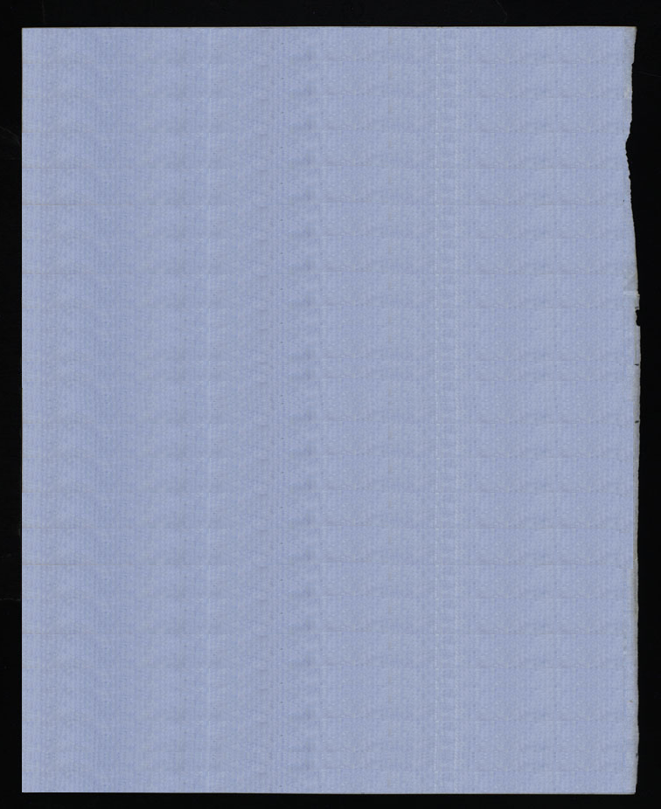*

*We arrived at Flat Rock after night and could not find water. After we had gone to sleep some Paiutes came to us and told us where the water was. so we went to it the next morning and remained that day. After Breakfast I took my gun and started out hunting. I climbed the highest peak I could ‘ find and discovered traces of ancient ruins. A wall built of cobble stones, similar to that at the President’s, extending upwards of 4 miles north and south. in some places it is 15 feet high. But has been injured very much by earthquakes or convulsions of some kind. Upon a closer examination I found another wall about eight rods from the first running parallel with it. I went to camp and told the brethren what I had found, some doubted and some believed, so we all went and examined and found it as related. and many were the questions in relation to who done it, when was it done, &c. &c. In going up between the walls we felt that we were walking in one of the streets of an ancient city. I had not time to explore as thoroughly as I would like to do.*

*Now for these ORIBES. They are over me and around me looking at me right. they all wear blankets which they make. they are very industrious. their houses are built of undressed rock and mortar. from one to four stories high. they are very kindn to me and “all is Right.”*

*Please give my regards to aunt Bathsheba and susan. George and Bathsheba and all the Folks, and believe me Your Brother in the Gospel*

*M.J.Shelton.*

*I will tell you more when I see you – which will probably be next fall.*

*M.J.S.*