Alphabet Table from the Deseret First Book

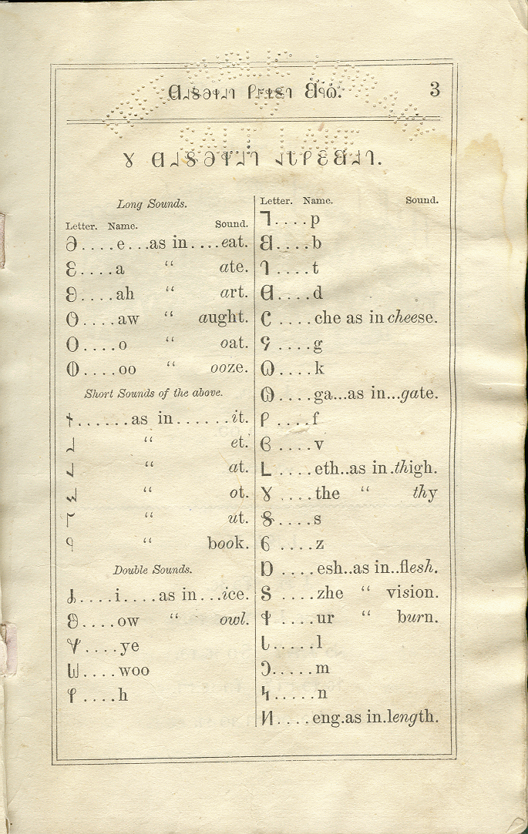

Alphabet Table from the Deseret Second Book

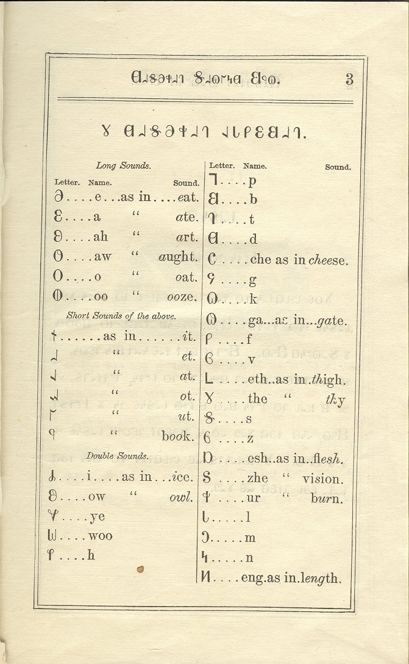

Alphabet Table from the Book of Mormon Part I

